Phase 1:

Victim Environment:
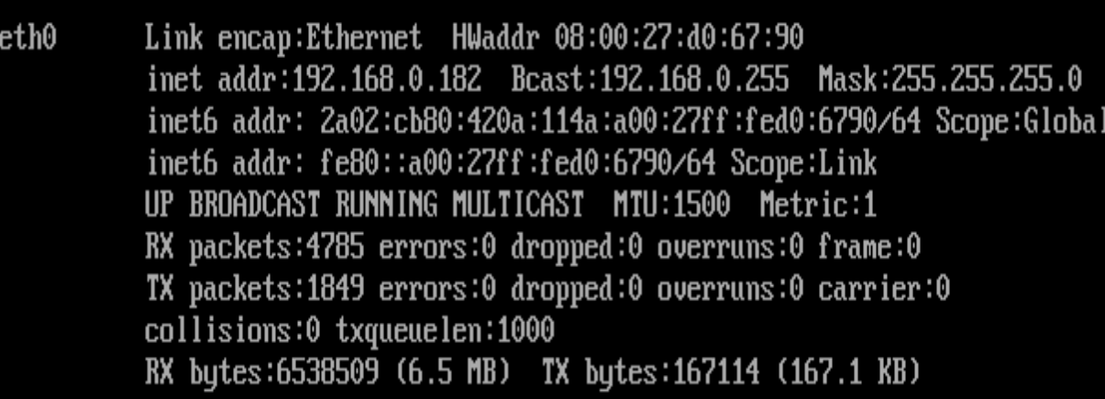
Ip of the victim machine: 192.168.0.182
Attacker Environment:
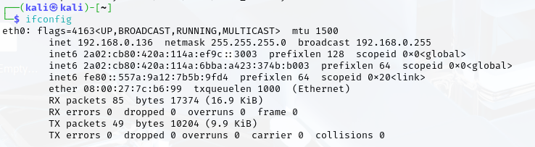
Ip of the attacker 192.168.0.136

Ensure connectiveity:
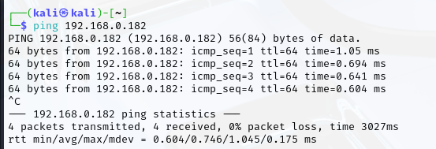
ping sent and received from attacker to victim

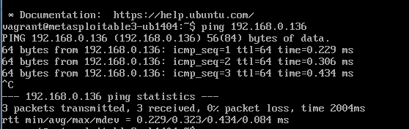
ping sent and received from victim to attacker

Donwload and run metasploit:
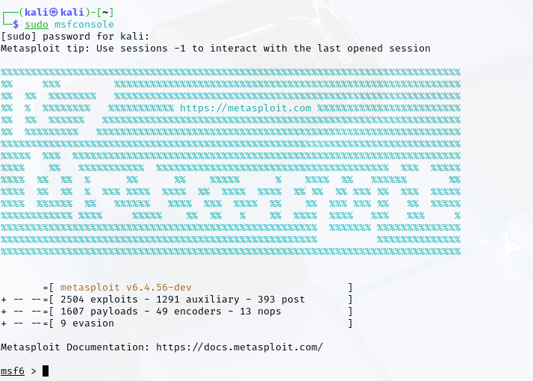
Installed and run Metasploit successfully.

Task 1.1:
The chosen service is SSH

Part 1 gain access:

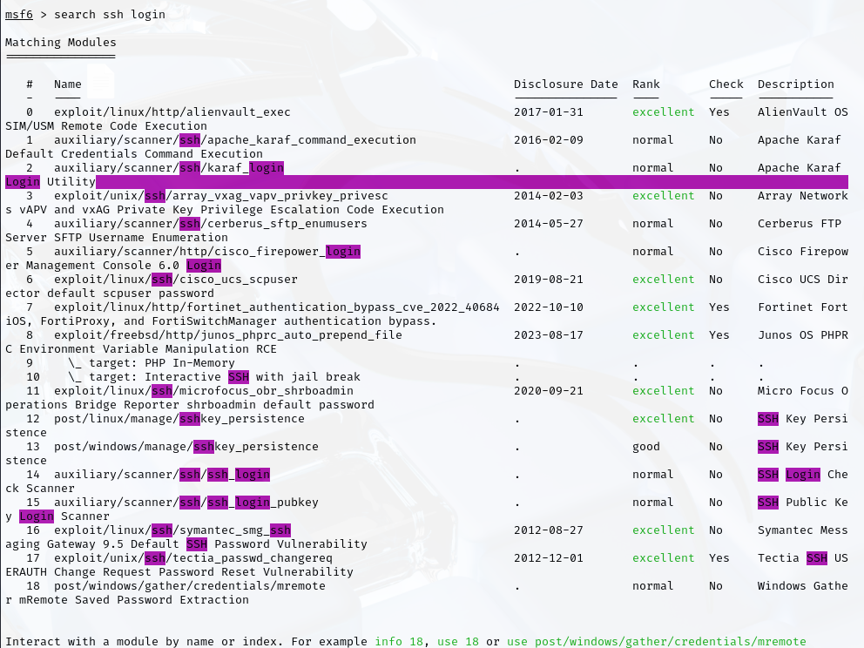
First we need to gain access to ssh service, so we search for possible exploits. Exploit 14 is the most suitable to gain access to ssh service so we will choose that.
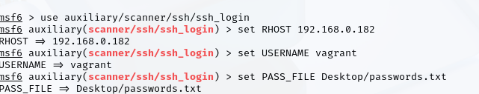
After choosing the service, we set the victim environment, followed by a known default username (vagrant), and a known passwords file to brute force into ssh.
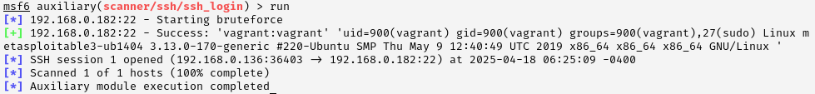
After running the attack and waiting for some time we were able to gain access and open an ssh session, which leads us to the second part of the attack.

Part 2 use SSH session to inject backdoors or steal info:
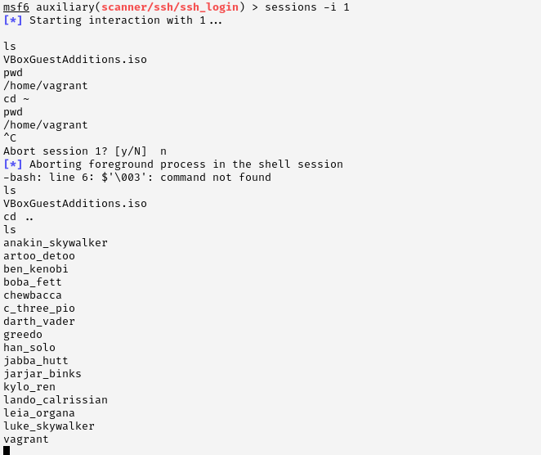
Using the session, we can gain access to all files and folders in the system.
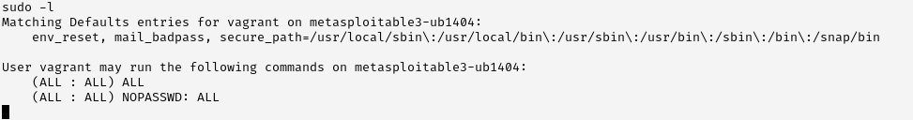
Gained root access and can run all commands using the compromised session.
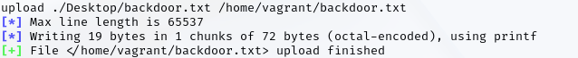
Uploaded a backdoor to the victim machine.

Task 1.2:

Custom python script to do ssh brute force
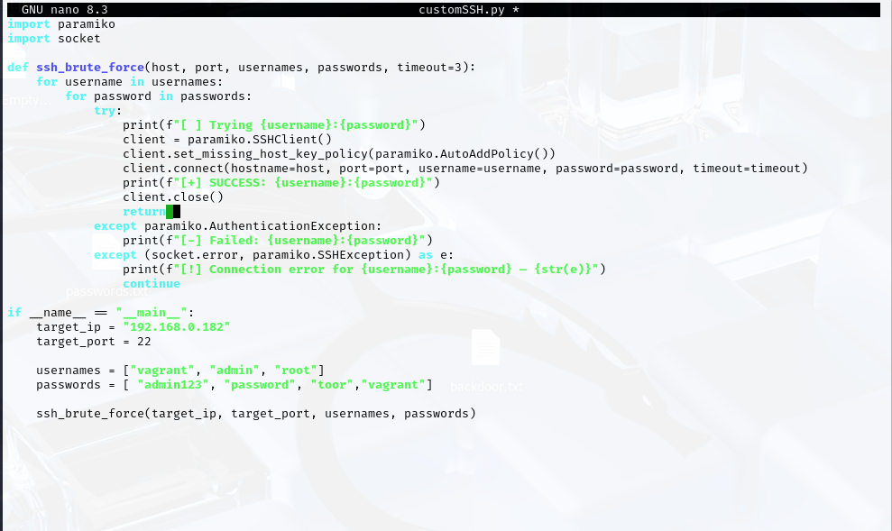
For testing, the usernames and passwords are in lists.
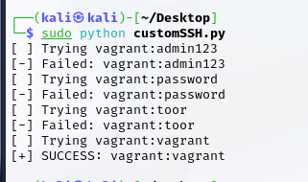
As can be seen, the attack succeed and we were able to gain access using the custom script.

